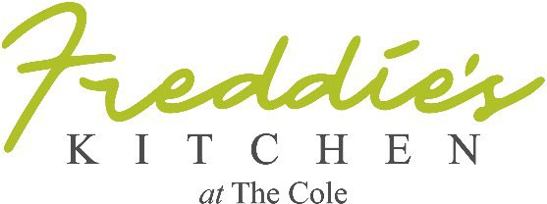

New Year’s Eve Dinner
Sample Only – Final Draft Available Mid December

Welcome Amuse Bouche ~ Hamachi Crudo

Your Choice of:
Peppered Cabernet Crab Bisque
or
Cassolette d ’escargot a la Crème
or
Organic Heirloom Tomato Salad, pesto, olives, roasted pine nuts, balsamic
or
Crispy Kurobuta Pork Belly, sweet and spicy sauce, white truffle oil

Jidori Farm, Airline Breast of Chicken, Roasted Garlic Beurre Blanc

or
Australian Barramundi a la Plancha, grenobloise

or

Grilled Elk Medallions, juniper blueberry balsamic reduction

or

Grilled Vegetable Wellington, tomato pesto coulis

or

Angus Beef Short Ribs Pave, French Perigord winter truffle jus

Tahitian Vanilla Bean Crème Brûlée
or
Apple Croissant Bread Pudding with Calvados Crème
Or

Dark Chocolate Mousse

~ All deserts served with a complimentary glass of Jacquart Brut Mosaique Champagne

$95 per person / tax and gratuity not included. Corkage fee $25

Owner / Executive Chef Frederic Pierrel and Staff
Wish You and Yours
Bon Appétit & A Very Happy New Year!

Please join us at the bar later for fun!!

